PROJECT REPORT

ENVIRONMENTAL MONITORING

USING IOT



SUBMITTED BY;

R.ARUNKUMAR – 812921106004

M.HARITHABANU - 812921106016

S.MAHALAKSHMI - 812921106024

M.VIJAYARAGAVAN - 812921106037

TABLE OF CONTENT

1.ABSTRACTS

2.OBJECTIVES

3.INTRODUCTION

-PROJECT OVERVIEW

-PURPOSE

4. LITERATURE SURVEY

-EXISTING PROBLEM

-PROPOSED SYSTEM

-INTERNET OF THINGS

5.BLOCK DIAGRAM

-SYSTEM CONFIGURATION

-ARDUINO MICROCONTROLLER

-SENSOR(DHT11)

-WI-FI

-MQ135 SENSOR

-MQ9 SENSOR

6.EXPERIMENTAL RESULT

7.RESULT AND DISCUSSION

8.COMPONENTS

-INPUT COMPONENTS

-COMMUNICATION INTERFERENCE

-OUTPUT COMPONENTS

-MAJOR SOFTWARE USED

9.CODING AND SOLUTION

-FEATURES 1

-FEATURES 2

-PROGRAM

-OUTPUT

10.ADVANTAGES & DISADVANTAGES

11.FUTURE SCOPE

12.CONCLUSION

ABSTRACT

its ability, investigation of various kind's organization arrangement for ceaseless information assembling and checking Different instruments used to investigate the information put away on the cloud The internet of Things is known to play a critical capacity in regular daily existence the entire way through inescapable sensor correspondence networks the epitomize our general climate.

Such frameworks gives the plan capacity to screen fundamental actual occasions produced information that can be moved and put away in the Cload from which it is feasible to share this data by means of utilization and choice is made to make a move for a happened occasion Ecological Monitoring framework sex sensors for encompassing area moistness and temperature These information could be used to AUME transient conduct like gadget becoming hot or getting cool down and other long haul insights of the gadgets.

The detected information will be sent to cloud space, and the cloud is gotten to by u Smartphone application and results are introduced to end clients. The review is done the sort sensors, microcontroller.

The Internet of Things consist of smart connected devices in homes, businesses and cities that has the ability communicate over an Internet without human-to-human or human-to-computer involvement. IoT communication standards and platforms has a high potential for a wide range of applications in different domains. Collecting the data by a large number of sensors, is a challenging task because of many open issues. Effective collection and distribution are crucial for classes of smart city services such as environmental monitoring, public security, transportation, and other. Unfortunately there are many connection gaps between the raw sensor data and the information context that are needed by high-level services and applications. Utilization of some Semantic Web standards provide better integration of sensor with applications, but still is far from being solved. Therefore, we have analyzed selected standards, protocols, and architectures and have suggested some enhancements into “common semantics” model.

OBJECTIVES

Developing a low cost IOT based environmental monitoring system to monitor a person’s surrounding environment. Analyzing the available products on the market and coming up with products that meet the cost and the accuracy of the demandAnalyzing the potential data breach in the system and ways to tackle them.

1. Real-time Data Collection: IoT sensors gather data on various environmental parameters such as temperature, humidity, air quality, and more.

2. Data Analysis: Analyzing: the collected data to detect trends, anomalies, and patterns in the environment.

3. Early Warning Systems: Developing systems to provide early warnings for natural disasters like floods, earthquakes, or forest fires.

4. Environmental Conservation: Monitoring ecosystems and wildlife to support conservation efforts.

5. Energy Efficiency: Optimizing energy consumption in buildings and industries to reduce environmental impact.

6. Air and Water Quality: Continuous monitoring of air and water quality for pollution detection and control.

7. Agriculture: Using IoT for precision agriculture, including soil moisture monitoring and crop health assessment.

8. Urban Planning: Gathering data for smarter urban planning and development, including traffic management and waste disposal.

9. Public Health: Monitoring environmental factors that may impact public health, such as disease vectors or allergen levels.

10. Research and Education: Providing valuable data for research and educational purposes to increase awareness about environmental issues.

INTRODUCTION

Project overview:

there is a growing need for an atmospheric environment monitoring system capable of effectively measuring and analyzing contaminants in the air as the hazard of air pollution becomes serious.

For this purpose, a government-led air monitoring system in most countries is installed to provide information on air pollution to users by observing the atmospheric environment , and air pollution information observed through the National Ambient air quality Monitoring Information System (NAMIS) of Korea Environment Corporation is also provided to the public.

However, the NAMIS consists of high-cost atmospheric environment measurement equipment, and thus, it is very expensive to build a new atmospheric environment measurement station.

Therefore, there is a desperate need for an atmospheric environment monitoring system that can effectively provide atmospheric environmental observation results to public facilities such as kindergartens and schools, or homes and commercial facilities in the area where the NAMIS' atmospheric environment measurement station is not operated. In this paper, we propose an IoT-based atmospheric monitoring system using LTE mobile communication network (Long Term Evolution) in order to solve the problems such as cost and the restrictions in the installation place and space of existing atmospheric environment measuring equipment.

The proposed system has been developed as a prototype that measures various air environment information including fine dusts and ozone in the atmospheric environment measuring device and transmits the packet including the measured information as well as the location and operation status of the measuring device to the LTE network and analyzes them on the server.

It is an open source Internet of Things application and API in store and retrieve data from the sensors using the HTTP Protocol over the Internet.

Thingspeak is an loT analytics platform service that allows you to aggregate, visualize, and analyze live data streams in the cloud.

The cloud utilizes the operations of Graphical visualization and available in the form of virtual server for the users and the objects are communicated with the cloud via possible 'wireless internet connections available to the users and the majority objects uses the sensors to tell regarding the environmental analogue data. The measurements,thus received can be viewed in these scripts such as JSON, XML and CSV.

In the proposed system, the environmental parameters can directly be accessed by the user, thus eliminating the need for third parties.

In order to achieve a low budget IoT based environment monitoring system (IoT-EMS) in volunteer computing environment, inexpensive sensor components are used for measuring the parameter.We have mainly taken Temperature and humidity sensor, carbon monoxide sensor, and carbon dioxide sensor for building the system.

The measured parameters are transmitted to the microcontroller device, which are then sent to the MySQL web database server using the Quad Band GSM/GPRS SIM800 add-on shield forAurdiuno. The values stored in the database can be periodically used for analysis and such a statistical computing is performed using the R programming and RS studio.

Purpose:

Environmental monitoring in IoT allows for early detection of environmental hazards such as natural disasters (e.g., earthquakes, floods, hurricanes), enabling timely warnings and evacuation plans to ensure public safety.

By tracking resource consumption, such as water and energy, IoT can help conserve valuable resources, reduce waste, and lower environmental impact.

IoT data on temperature, humidity, and greenhouse gas levels contribute to climate research and help in developing strategies to mitigate climate change effects.

LITERATURE SURVEY

Existing problem:

Bluetooth wireless technology is inexpensive, short-range radio technologies that eliminates the need for proprietary cabling between devices such as notebook PCs, handheld PCs, PDAs, cameras, and printers and effective range of 10 - 100 meters and generally communicate at less than 1 Mbps.

Bluetooth uses specification of IEEE 802.15.1 standard. ZigBee is one of the protocols developed for enhancing the features of wireless sensor networks. Characteristics of ZigBee are low cost, low data rate, relatively short transmission range, scalability, reliability, flexible protocol design.

It is a low power wireless network protocol based on the IEEE 802.15.4 standard. ZigBee has range of around 100 meters and a bandwidth of 250 kbps. Traditionally ZigBee and other IEEE 802.15.4 based protocols have been considered for sensor network applications due to their energy-efficient design.

However, recently developed power-efficient Wi-Fi components, with appropriate system design and usage model, have become a strong candidate in this domain. Other technologies like Bluetooth, zigbee, RFID has limitations of transmission range. Radio Frequency Identification (RFID) is a system that transmits the identity of an object or person wirelessly using radio waves in the form of a serial number.

RFID technology plays an important role in IoT for solving identification issues of objects around us in a cost effective manner. The other communication technologies like ZigBee, RF Link can make the communication nearly in the same range of Wi-Fi but they can’t broadcast the information as they can only communicate peer to peer.

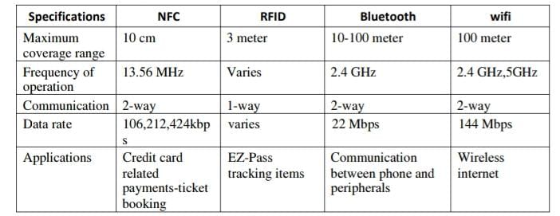

Low-power Wi-Fi promises multiple years of battery lifetime while providing easy integration to existing infrastructure with built-in IP-network compatibility. Wireless Fidelity (Wi-Fi) is a networking technology that allows computers and other devices to communicate over a wireless signal.

Proposed system:

The goal of building a smart city is to Improve quality of life by using technology to improve the efficiency of services and meet residents needs. Information and Communication Technology allows city officials to interact directly with the public to tell what is happening in the city, how the city is evolving, and how to enable a better quality of life. We are going to monitor the environment by using IOT technology. Consider an area that is being surveyed for estimating how much the area is affected by pollution. The constituents of air along with its proportion are calculated and if it is higher than normal then the officials are intimated about it. In this proposed make the climate changes te party stager des faternet of Things (IoT) in a montcommication paradigm, im which the objects will be equipped with marocommolars seves and stabile protocol stack the will make thers are with me another and with wer. This paper frapas a prototype of vamiems smatrali vymar to vpisal information firm atmay of unsur the database. This app allows us to stal paratutes from atywhuru in Ene. The leta set of main there nohin nanely see sodes, the wind web serve. The must nudes la remote heaten solent the ashematan found conditions and swed the des weshaly using Агиню патокоer at EP2 Wi-Fi mode the This paper posa vystem that san be use gases digestitamin angsedes.

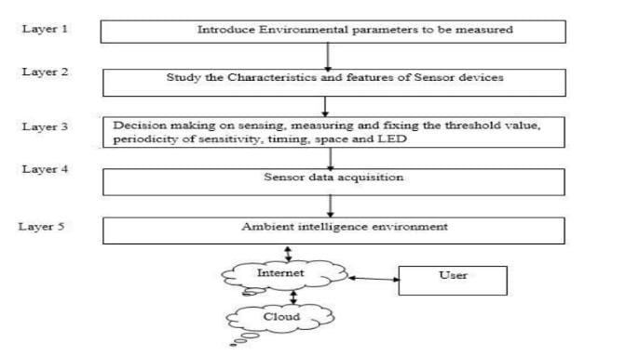

All unserm as menetes on the ardum menontroller and the state of the unices sand to the control section continamusly. The data aplooding is done by ESP 8206 Wi-Fi modde. The thit is apdando litt. Tht valtum of amnars am displayed on LCD. The buzma med ta male sound, if the beyond its threshold value for saving the people meday. The deve desped in this project is besd Асель UNO The Ankime bed with ling Speak glattening ESP216 Wi-Fi Made. The Thuny Speck is a popular IOT platform which nay lase and program. The ser data is an diaplayed anche LCD enfiost in Dhe montoeng KIT device.

Internet of Things (IOT):

The term “Internet of Things” (IoT) refers to the possibility of connecting sensors, actuators or any device to the Internet. It can lead to a significant change in our daily lives in the way we live and interact with the devices such as home appliances, smart meters, security sensors, HVAC systems, etc. The vision of Internet of Things calls for connectivity not only to consumer electronics and home appliances, but also to small battery powered devices which cannot be recharged. Such small devices, often various types of sensors and actuators, are required to sustain reliable operation for years on batteries even in the presence of heavy interference. The IoT is a technological revolution that represents the future of computing and communications.

BLOCK DIAGRAM

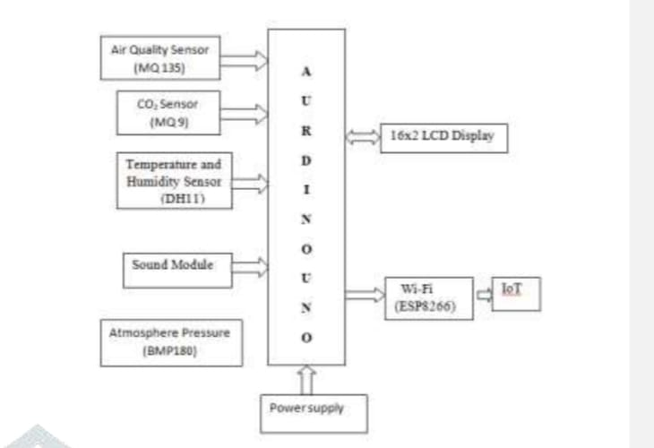

Arduino UNO is the central unit which acts as the main processing unit for the whole system. This is interfaced with the sensor chip to receive temperature and humidity as input readings. There by, integrated with the Wi-Fi module to produce output over receiving data from cloud. The microcontroller then initiates the sensor to receive data and transmit over the Internet via Ubi Dots cloud for further analysis.

SYSTEM CONFIGURATION:

Hardware used:

- Microcontroller

- Temperature Sensor

- Power supply

-WIFI

Software used:

- python

- Arduino compile

- Proteus

1.Arduino Microcontroller

Arduino is best described as a single-board computer that has deliberately been designed to be used by people who are not experts in electronics, engineering, or programming. It is inexpensive, cross-platform (the Arduino software runs on Windows, Mac OS X, and Linux), and easy to program. Both Arduino hardware and software are open source and extensible. Arduino is also powerful: despite its compact size, it one of the original navigation computers from the Apollo program, at abobe 1,3500/as.

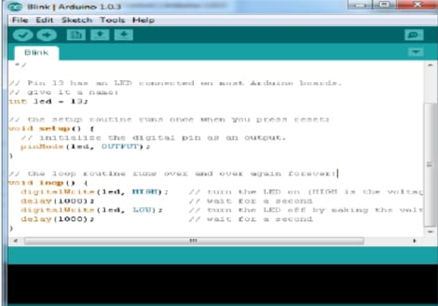

The core part of the system is the microcontroller, a central hardware component that interfaces with other components of the system. As the developing application requires a single sensor for monitoring temperature and humidity where no data is locally stored, Arduino UNO is selected as microcontroller which serves our purpose well due to Arduino is best described as a single-board computer that has deliberately been designed to be used by people who are not experts in electronics, engineering, or programming. It is inexpensive, cross-platform (the Arduino software runs on Windows, Mac OS X, and Linux), and easy to program.

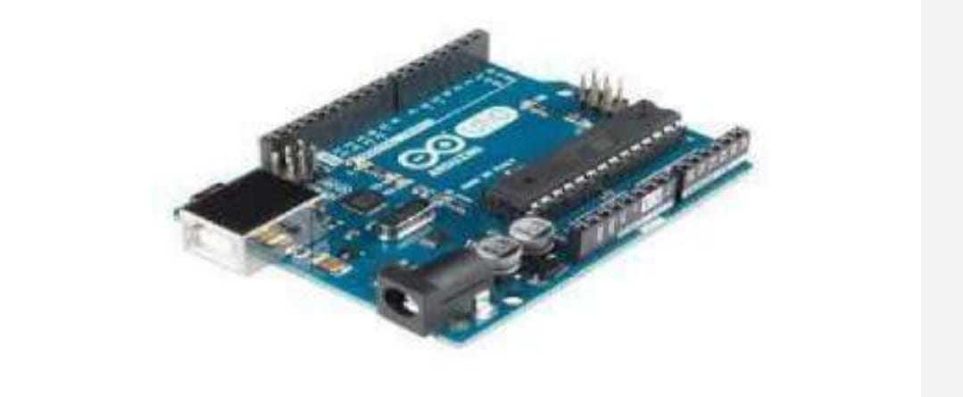

tiny An LED is a lamp made of various rare-earth metals, which give off a large amount of light when a current is run through them. The composition of the substances within the LED determine the particular wavelength of light emitted: green, blue, yellow, red, and even ultraviolet and infrared are among the possible colors. Technically, the LEDs used in our gadgets are “miniature LEDs,” tiny lamps with two wire leads, one long (called the anode) and the other a bit shorter (called the cathode). These come in various useful forms, including single lamps from 2mm to 8mm in diameter, display bars, and alphanumeric readouts, and can serve as indicators, illuminators, or even data transmitters.

2.sensors (DHT11)

The implementation in this paper is performed using s single sensor to monitor temperature and humidity for environmental monitoring. This purpose is served with the DHT11 composite sensor chip, hence is included in the system for reading temperature and humidity at the same time. The outrating characteristic feature of this sensor is its high reliability and long-term stability. This is also popularly used because this is highly economical with smaller dimensions, quick response, strong anti-interference ability, digital signal output, and precise calibration. Also this is easily interfaced with the Arduino UNO board. The figure shows a picture of the DHT composite sensor which we used in our framework. It can read temperature ranging from 0 to 50°C and humidity ranges from 20 to 90% RH. It has a signal transmission range of 20m. To interface it with Arduino UNO, we connected the Ground and VCC of the DHT11 sensor with the Ground and 5V of the Arduino. Then we connect the Data pin of the DHT11 to pin 2 of the Arduino. Then we installed the DHT library and run the code for getting it started The DHT11 is a basic, ultralow-cost digital temperature and humidity sensor. It uses a capacitive humidity measuring element (with a measurement range of 20% to 80% and accuracy of ± 5%) calibrated against an NTC thermistor (with a measurement range of 0°C to 50°C and accuracy of ± 0.2°C) to measure the surrounding air and gives a calibrated digital signal output of the temperature and relative humidity (no analogue input pins needed). The only real downside of this sensor is that you can only get new data from it once every 2 seconds.

The DHT11 sensor module is a combined module for sensing humidity and temperature, which gives a calibrated digital output signal. A DHT11 gives us very precise values of humidity and temperature and ensures high reliability system and long-term stability. The automatic measurement and transmission of temperature and humidity of data from remote stations using wireless systems. It also involves in Arduino microcontrollers in meteorological sensors. The DHT11 sensor has a resistive type humidity measurement has its component and NTC type temperature measurement component with an 8-bit microcontroller inbuilt which has a fast response and cost effective and available in 4-pin or 3-pin single row package.

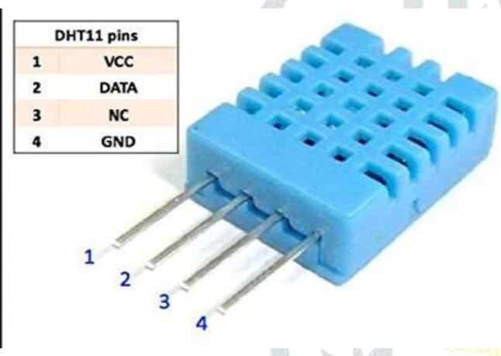

The DHT11 module works on serial communication is single wire communication. This module sends data in form of pulse train of specific time period. Before sending data to Arduino, it needs some initialize command with a time delay. And the whole process time is about 4 ms. the single-wire serial interface makes system integration quick and easy. Its small size, low power consumption and up-to-20-meter signal transmission making it the best choice for various applications, including those most demanding ones . It is convenient to connect and special packages can be provided according to users’ request. This proposed system can provide a convenient method for effective monitoring of temperature and humidity in real time .

3.wi-fi:

coder so upload madings from all, armor so he peal Thingles, Andris UNO thest with Wi-Fi ESP6W Fimicstep with a full TCP on the 3.3V this point by Arduis UNO in our system. The male is confidh AT und ander required since to bend The mall an with a bit lem and we gas being connected to Wi-Fi dough which be mode and the cates over the Istemet. After seting our EP26 ale, we connected with A UNO and the pg Anh UNO to config the ESP W TCP and send das Thingspak serv which is an open la phat to any

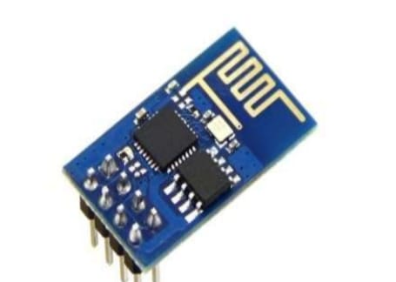

ESP8266 Wi-Fi module which is having TCP/IP protocol stack integrated on chip. So that it can provide any microcontroller to get connected with Wi-Fi network. ESP8266 is a preprogrammed SOC and any microcontroller has to communicate with it through UART interface. It works with a supply voltage of 3.3v. The module is configured with AT commands and the microcontroller should be programmed to send the AT commands in a required sequence to configure the module in client mode. The module can be used in both client and server modes. Once it gets connected in a Wi-Fi network, we’ll get one IP address which is accessible in its local network. The module is additionally having 2 GPIO pins alongside UART pins. It is also having inbuilt SPI protocol by using the two pins of UART as data lines and by configuring the two GPIO pins as control lines and clock signal. It is also having 1MB on-chip flash memory. Internally it is having power management unit with all regulators and PLLs.

4.MQ 135 SENSOR:

MQ-135 gas sensor applies SNo2 which has a lower conductivity in clear air as a gas sensing-material .In an atmosphere where the may be polluting gas,the conductivity of gas sensor raise along with the concentration of polluting gas. MQ-135 performs a good detection to sulfide and benzyne steam. It ability to detet various harmful gas and lower cost make MQ-135 an ideal choice of different application of gas detection. The gas sensing material used in the MQ135 gas sensor is tin dioxide (SnO2), which has low conductivity in clean air. When there is polluted gas in the environment where the sensor is located, the conductivity of the sensor increases with the increase of the concentration of polluted gas in the air. The MQ135 gas sensor has a high sensitivity to ammonia, sulfide, and benzene-based vapors, and is ideal for monitoring smoke and other harmful gases. This sensor can detect a variety of harmful gases and is a low-cost sensor suitable for a variety of applications.

The IoT-EMS mainly use three types of sensors such as temperature and humidity sensor, CO sensor, and CO2 sensor. These four parameters are the primary environmental factors which changes the quality of the environment. The ATmega 8-bit microcontroller controls the communication by receiving the data from the sensors periodically. The 3 sensors are briefly discussed as follows: 1) DHT11 [32]: DHT11 sensor is a low-cost sensor module mainly u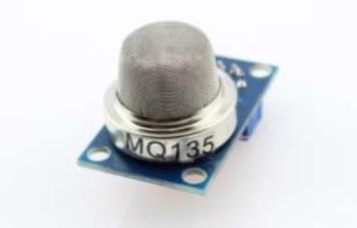sed for measuring the temperature and humidity at a location. It consists of a humidity sensor and a thermistor to measure the air. It works at 3–5 V power supply. The maximum current draw is 2.5 mA. It measures 20–80% humidity with a accuracy of 5%, and it can measure the temperature from 0–50 degree centigrade with an accuracy of ±2 degree centigrade. The module used has 3 pins such as power (Vcc), Data, and Ground (Gnd). Fig. 3a shows the DHT11 sensor used for the design of IoT-EMS. MQ-7 [33]: It is a low cost sensor used for measuring CO concentrations in the air. It can measure CO concentrations from 20 to 2000 ppm. It works at 5 V.

#### 5. MQ9 SENSOR :

The MQ-9 is a Carbon Monoxide (CO) sensor suitable for sensing CO concentrations in the air. It can detect CO-gas concentrations anywhere from 20 to 2000 ppm.It make detection by method of cycle high and low temperature, and detect CO at low temperature.It is widely used in domestic CO gas leakage alarm, industrial CO gas alarm and portable CO gas detector The gas sensitive material used in MQ-9 gas sensor is SnO2, which is of lower electrical conductivity in clean air.

#### WhatsApp Image 2023-10-28 at 1.11.30 AM - Copy.jpeg

It detects carbon monoxide with low temperature (heated by 1.5V) through high-low temperature cycles. The electrical conductivity of the sensor increases with the increase of the carbon monoxide concentration in the air. The change of electrical conductivity can be converted to the output signal corresponding to that of the gas concentration by using a simple circuit. The sensitivity of MQ-9 gas sensor to carbon monoxide is quite high, so it can be used to detect various gas containing carbon monoxide. It is a low-cost sensor suitable for a variety of applications.

The system consists of temperature sensor, humidity sensor, LDR and pressure sensor. These 4 sensors will measure the primary environmental factors like light intensity, temperature, pressure and relative humidity respectively. All these sensors will gives the analog voltage representing one particular weather factor. The microcontroller will converts these analog voltages into digital data.

#### EXPERIMENTAL RESULT

The Experimental equipment shown in Fig.7 helps in the acquisition of the data for the various parameters of the environment in which the system is installed. 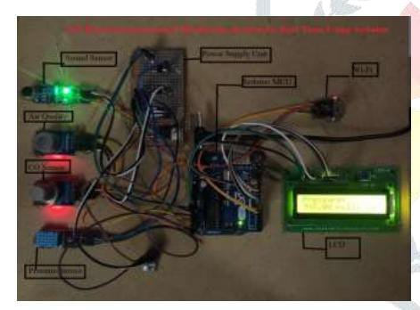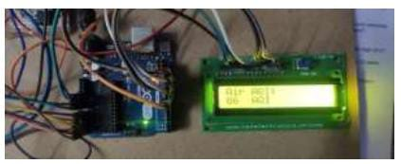

#### WhatsApp Image 2023-10-28 at 1.13.11 AM.jpeg

#### WhatsApp Image 2023-10-28 at 1.20.13 AM.jpegWhatsApp Image 2023-10-28 at 1.13.18 AM.jpeg

#### RESULT AND DISCUSSION

The algorithms are implemented in the RStudio platform on the generated real-time dataset having 10,000 instances of the environment data. A separate course of action is followed for regression-based algorithms (SVM and Multiple Regression) and for classification-based algorithms (MLP and k-NN). For regression-based algorithms, the dataset is first imported in the RStudio IDE, and if NA values are present then those are omitted. Then the dataset is divided into training and testing data in a 6.5: 3.5 ratio. Then we plot the response variable from the dataset to observe the convergence of data points in the space. The respective libraries are imported for the algorithms to be able to use their corresponding functional formulas. Then we build the algorithm specific model, and then proceed for the hyper parameter tuning. Depending on the tuning results, the best model is selected, and it is used to generate the confusion matrix. From the above results, the Standard Error of the estimate is calculated which is the mean square error (MSE). The mathematical squared root of the MSE gives the root mean square (RMS) value of the error in predictions. For classification-based algorithms, the above procedure is followed as well with the minor exception of categorizing the data points to separate classes/labels using min-max normalization transformation. For each of the algorithms tested on the dataset, a confusion matrix is obtained. In case of classification-based algorithms, such matrices denoted the accuracy in classifications as well as the misclassification error.

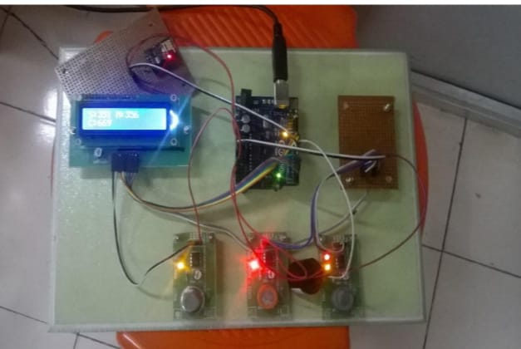

In this case, the accuracy is calculated on the basis of classification of temperature data in between the range of 21.5–23.5 degree centigrade. Rest of the data lying outside this range is treated as misclassification error. So, accuracy is denoted by (1-misclassification) error. On the other hand, in regression-based algorithms the confusion matrices denoted the error in prediction of the object with reference to the model as part of the R Language syntax used during analysis. The output generated from the models is denormalized and the performance of the developed models is assessed. MSE is used as a performance metric in this work by generating a trained model, and then ranking the predicted response with the desired response. The performance of MLP trained with back-propagation algorithm, k-NN, SVM, and multiple regression algorithms for different orders of data in terms of MSE which is depicted in a graph below in Fig. 11. From the obtained results it has been observed that the order of dataset does not have any significant effect on the performance of the algorithms. In classification-based algorithms, k-NN outperforms MLP having an average of about 97% accuracy irrespective of the dataset, whereas MLP has an accuracy of about 64%. Fig. 8 shows the neural network model for the dataset. There are 3 inputs with IASC, 2022, vol.32, no.3 1503 two processing/hidden layer units and one unit in the output layer. It also mentions the error in classification and the number of epochs in which the process is completed. Fig. 9 shows a confusion matrix of k-NN model. It helps in identifying the misclassification error and in calculating the accuracy in classification. Similarly, in the regression aspect, SVM performs better than multiple regression for all orders of the dataset taken into consideration during the experimentation. SVM classifier has MSE of 0.029, whereas multiple regression has MSE of 1.89. Fig. 10a shows the desired output of SVM. It is the response field i.e., temperature taken from the test data plotted against its index value. Fig. 10b shows the predicted output of SVM as given by the SVM model against the number of observations in the test data, and it is obtained by giving the test data as the object to predict the function. Fig. 10c illustrates the performance of SVM model. The darker shaded regions denote the best performance of the model for the corresponding epsilon and cost parameters. As we move towards the lighter shaded region, the performance of the model is reduced. Fig. 10d shows the expected performance of the multiple regression model in predicting the response variable data where the red line denotes the model fitting meaning accuracy of predictions when compared to the actual test data. The hyper parameter tuning in case of SVR is a special case to observe how and cost parameters affect the performance of the algorithmic predictions.

COMPONENTS

#### Input Components:

* + -Temperature sensor – LM 35
  + -Humidity sensor – ESP 8266
  + -Arduino UNO microcontroller
  + -Power supply

Communication Interfaces:

* + -Wired USB Connectors
  + -Wireless Fidelity (Wi-Fi) module

Output Components:

* IoT device – smart phone
* LCD (Optional)

Major Software Used:

* Arduino IDE

Coding and sollutions

Features1:

IoT devices are equipped with temperature and humidity sensors to collect real-time data. They record and store data over time, allowing for historical analysis and trend detection. IoT devices use wireless protocols like Wi-Fi, Bluetooth, or LoRa to transmit data to a central hub or cloud platform.Users can access the data and monitor conditions remotely through a web or mobile app. Systems can send alerts via SMS, email, or notifications when temperature or humidity levels go outside specified thresholds.

Features2:

IoT platforms can analyze data for patterns, anomalies, and trends, aiding in decision-making and predictive maintenance. Data can be integrated with other systems like HVAC, automation, or security systems for better control and response. Monitoring can lead to energy savings by optimizing heating, cooling, and ventilation systems. Systems can provide historical data for compliance, research, and reporting purposes. IoT solutions can be scaled up to monitor environments in various locations. Devices are designed for long battery life to reduce maintenance needs.

Program:

# SPDX-FileCopyrightText: 2018 Brent Rubell for Adafruit Industries

#

# SPDX-License-Identifier: MIT

#

# Adafruit IO Environmental Monitor for Feather or Raspberry Pi -

# an internet-enabled environmental monitor

# Import standard python modules

import time

# import Adafruit Blinka

import board

import busio

# import CircuitPython sensor libraries

import adafruit_sgp30

import adafruit_veml6070

from adafruit_bme280 import basic as adafruit_bme280

# import Adafruit IO REST client

from Adafruit_IO import Client, Feed, RequestError

# loop timeout, in seconds.

LOOP_DELAY = 10

# Set to your Adafruit IO key.

# Remember, your key is a secret,

# so make sure not to publish it when you publish this code!

ADAFRUIT_IO_KEY = 'YOUR_AIO_KEY'

# Set to your Adafruit IO username.

# (go to https://accounts.adafruit.com to find your username)

ADAFRUIT_IO_USERNAME = 'YOUR_AIO_USERNAME'

# Create an instance of the REST client

aio = Client(ADAFRUIT_IO_USERNAME, ADAFRUIT_IO_KEY)

try: # if we already have the feeds, assign them.

tvoc_feed = aio.feeds('tvoc')

eCO2_feed = aio.feeds('eco2')

uv_feed = aio.feeds('uv')

temperature_feed = aio.feeds('temperature')

humidity_feed = aio.feeds('humidity')

pressure_feed = aio.feeds('pressure')

altitude_feed = aio.feeds('altitude')

except RequestError: # if we don't, create and assign them.

tvoc_feed = aio.create_feed(Feed(name='tvoc'))

eCO2_feed = aio.create_feed(Feed(name='eco2'))

uv_feed = aio.create_feed(Feed(name='uv'))

temperature_feed = aio.create_feed(Feed(name='temperature'))

humidity_feed = aio.create_feed(Feed(name='humidity'))

pressure_feed = aio.create_feed(Feed(name='pressure'))

altitude_feed = aio.create_feed(Feed(name='altitude'))

# Create busio I2C

i2c = busio.I2C(board.SCL, board.SDA)

# Create VEML6070 object.

uv = adafruit_veml6070.VEML6070(i2c)

# Create BME280 object.

bme280 = adafruit_bme280.Adafruit_BME280_I2C(i2c)

bme280.sea_level_pressure = 1013.25

# Create SGP30 object using I2C.

sgp30 = adafruit_sgp30.Adafruit_SGP30(i2c)

sgp30.iaq_init()

sgp30.set_iaq_baseline(0x8973, 0x8aae)

# Sample VEML6070

def sample_VEML():

for _ in range(10):

uv_raw = uv.uv_raw

return uv_raw

while True:

print('Reading sensors...')

# Read SGP30.

eCO2_data = sgp30.eCO2

tvoc_data = sgp30.TVOC

# Read VEML6070.

uv_data = sample_VEML()

# Read BME280.

temp_data = bme280.temperature

# convert temperature (C->F)

temp_data = int(temp_data) * 1.8 + 32

humid_data = bme280.humidity

pressure_data = bme280.pressure

alt_data = bme280.altitude

print('sending data to adafruit io...')

# Send SGP30 Data to Adafruit IO.

print('eCO2:', eCO2_data)

aio.send(eCO2_feed.key, eCO2_data)

print('tvoc:', tvoc_data)

aio.send(tvoc_feed.key, tvoc_data)

time.sleep(2)

# Send VEML6070 Data to Adafruit IO.

print('UV Level: ', uv_data)

aio.send(uv_feed.key, uv_data)

time.sleep(2)

# Send BME280 Data to Adafruit IO.

print('Temperature: %0.1f C' % temp_data)

aio.send(temperature_feed.key, temp_data)

print("Humidity: %0.1f %%" % humid_data)

aio.send(humidity_feed.key, int(humid_data))

time.sleep(2)

print("Pressure: %0.1f hPa" % pressure_data)

aio.send(pressure_feed.key, int(pressure_data))

print("Altitude = %0.2f meters" % alt_data)

aio.send(altitude_feed.key, int(alt_data))

# avoid timeout from adafruit io

time.sleep(LOOP_DELAY * 60)

OUTPUT:

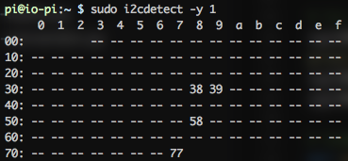

ADVANATAGES AND DISADVANTAGES

Advantages :

- User friendly

- High reliability

- Low power consumption

Disadvantages:

- Low communication

- Not efficient

FUTURE SCOPE

The future scope of IoT-based environmental monitoring is promising. It can lead to more efficient and sustainable resource management, better disaster prediction and management, and improved overall environmental quality. Some key areas of growth include:

1. Smart Cities: IoT can help cities monitor air quality, traffic, waste management, and energy consumption to create more sustainable and livable urban environments.

2. Agriculture: IoT sensors can optimize water usage, monitor soil conditions, and enhance crop management for improved agricultural sustainability.

3. Wildlife Conservation: IoT-enabled devices can track and protect endangered species by collecting data on their habitats and behavior.

4. Disaster Management: Real-time environmental monitoring can aid in early warning systems for natural disasters like hurricanes, floods, and wildfires.

5. Air and Water Quality: IoT sensors can provide continuous monitoring of air and water quality, helping to identify pollution sources and take corrective actions.

6. Energy Efficiency: Smart buildings and grids can reduce energy consumption by adapting to environmental conditions in real time.

7. Health and Safety: IoT devices can provide real-time data on environmental factors affecting public health and safety, such as heatwaves and air pollution.

8. Research and Data Analytics: IoT-generated data can support scientific research and policy decisions for environmental protection and sustainability

Conclusion

Thus the KIT bord stemmental Muling System has been designed and anglemented. The Envermemal parsnoters momsfully via ESP 8206 Wi-Fimis. The omstry of the guves in the remote located ama viwwed through the Thing Spank woh wever. Tan prepect will prstet the people from the pollutant games. Itin now ef for the tuhutries to matrol the air palhitehead for the weke key. In ήται το και περίποest the project with ESP 1066-126 Wi-1 module and with the

wars which case the in desty in lut ESP-12E mushas han inhch Adams nimestier doos the awell star of the decire and samplifim the working mechanim. environmental monitoring can be enabled today by Mobile loT from mobile operators Mobile operators are strong, low risk, long term partners, well placed to meet all the needs of an environmental monitoring and management service secure communications network and management platform, access to open data and engagement with developers and platform providers. Mobile operators and Mobile lot are also future proofed, as they are based on international standards with a roadmap towards integration with future networks and future smart cities needs. Mobile loT also operates in licenced managed spectrum, so is a robust, scalable choice for all of a cities environmental management needs

Cities initiating environmental monitoring projects need to consider their mobile operator as a core partner and work alongside them to scope and implement environmental monitoring and associated data analytics Mobile operators can share their experience of previous deployments offer economies of scale and understand the intricacies of how to deploy in different environments. All parties in the value chain can benefit from having a mobile operator at the core of a programme, as the data generated can be controlled and managed throughout the value chain in a consistent accessible and secure manner

Environmental loT monitoring offer a city and other environmental stakeholders new ways to engage with the public and create important secondary benefits including economic growth and reduced traffic and pollution. The business model behind environmental sensing as a service is maturing now to a point where it is achievable, affordable and beneficial to a city. By ensuring that the cities strategy around communications, data and financing is robust, cities should move forward with their investigations and procurement of environmental monitoring services